PASSWORD CRACKING REPORT
W3-PM-FINAL | CYBERSECURITY | NETWORKWALKS

Cybersecurity Professional | Jonnah Nabwire
Batch | B083-Networkwalks
Date | 23 Sep 2026
Modules Completed | Password Cracking with JTR  Password Cracking with NW Tools
Target | Pdf files given
Permission | Yes
Phases Covered | Phase 1:Password Cracking with JTR  Phase 2: Password Cracking with NW Tools

1.Liability Disclaimer
I have conducted all cybersecurity activities strictly for educational and authorized purposes. I have only tested pdf files given I had permission or ownership. I accept no liability for any unauthorized or unlawful use of the tools or techniques presented.

2. Introduction
This practical exercise focuses on cybersecurity password cracking using JTR and Networkwalks tools e.g Hash calculator and Password Cracker

3.Tools Used
- Windows PC – Used to install and run Zenmap and identify the local IP address and LAN subnet.
- John The Ripper – is a cybersecurity tool used primarily for password security auditing and password recovery.
- Networkwalks tools

4.Activities
4.1.Password Cracking using John the Ripper GUI
I extracted the files “My Locked PDF1.pdf,My Locked PDF2.pdf, My Locked PDF3.pdf ” into hash using onlineHashCrack and saved the hashes in hash1.txt, hash2.txt, hash3.txt file then cracked it using JTR.The password i got were
- My Locked PDF1.pdf – good-luck
- My Locked PDF2.pdf - password1
- My Locked PDF3.pdf - 1qaz2wsx
The flags found are shown in the evidence section

4.2.Password Cracking using Networkwalks tools
I downloaded the encrypted PDF file (My Locked PDF1.pdf) to my PC from the lab page:
https://networkwalks.com/project-task-lab-password-cracking-with-networkwalks-tools/
I opened the Networkwalks Hash Calculator in my web browser:
https://networkwalks.com/hash-calculator/
I then uploaded the pdf file and i was converted to hash value.I then opened passwordCracker in my browser and pasted the hash value and started cracking
Password Cracker (Dictionary Attack) - Networkwalks Academy
I used the above procedure with My Locked PDF2.pdf and My Locked PDF3.pdf.
The passwords were;
- My Locked PDF1.pdf - password1
- My Locked PDF2.pdf - password1
- My Locked PDF3.pdf - 1qaz2wsx
The flags found are shown in the evidence section

5. RISK ANALYSIS
The use of John the Ripper (JtR) and NetworkWalks tools during password-security and network-security assessments involves several potential risks. These risks must be controlled by conducting activities only within authorized environments and using test accounts, systems, or networks approved for the assessment.
Password-cracking tools such as John the Ripper can be misused to attempt to recover passwords from systems without permission.
Password hashes, wordlists, recovered credentials, or other authentication information may contain sensitive information.
6.RECOMMENDATIONS
Based on the practical assessment involving John the Ripper (JtR) and NetworkWalks tools, the following recommendations are proposed:
- Users should only receive the permissions necessary to perform their responsibilities. This reduces the potential impact of compromised accounts.
- Users should receive regular training on password security, phishing, social engineering, account protection, and safe computing practices.
- Findings from security assessments should be documented, prioritized according to risk, and followed by appropriate remediation and verification.
- users should use long, unique passwords that are difficult to guess and should avoid common words, names, dates, and predictable patterns.

7.Evidences Collected
7.1 Using JTR
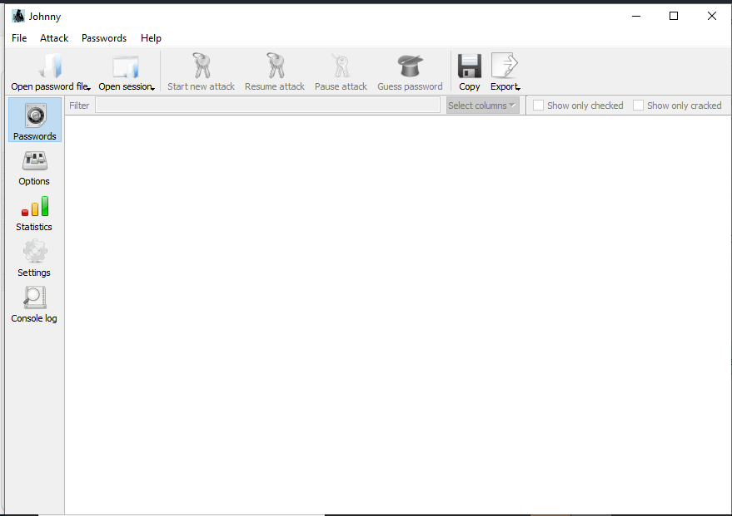
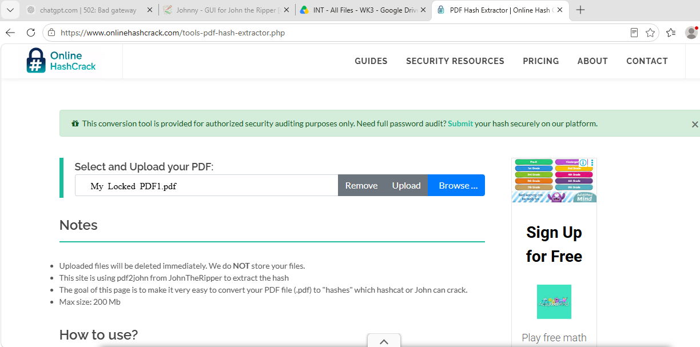
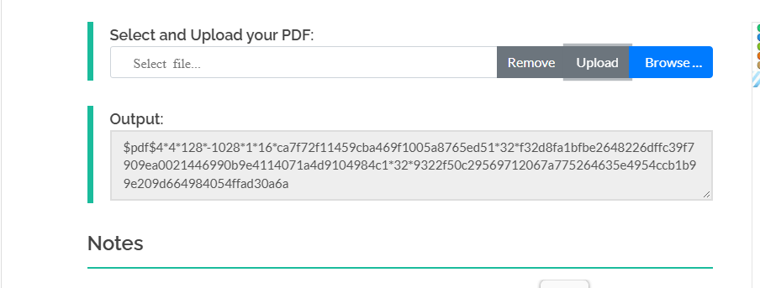
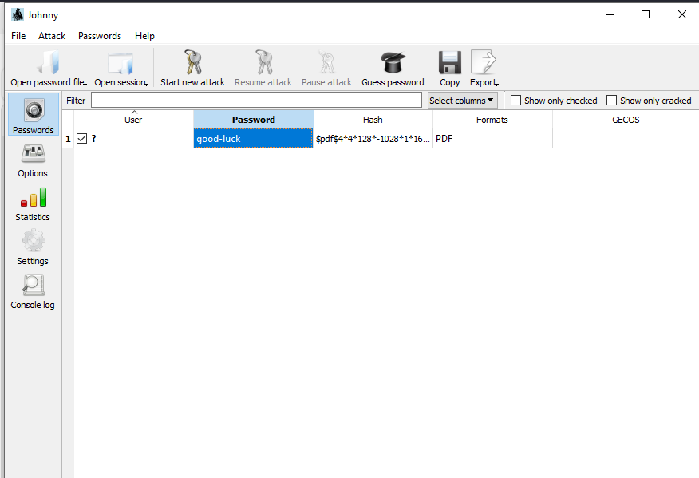

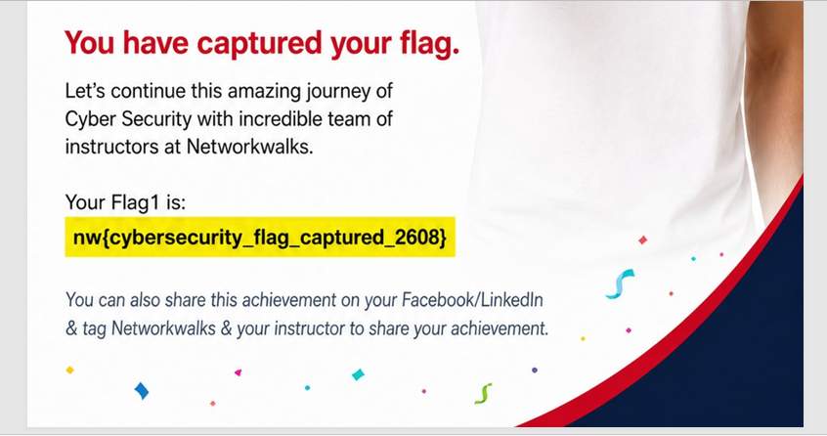
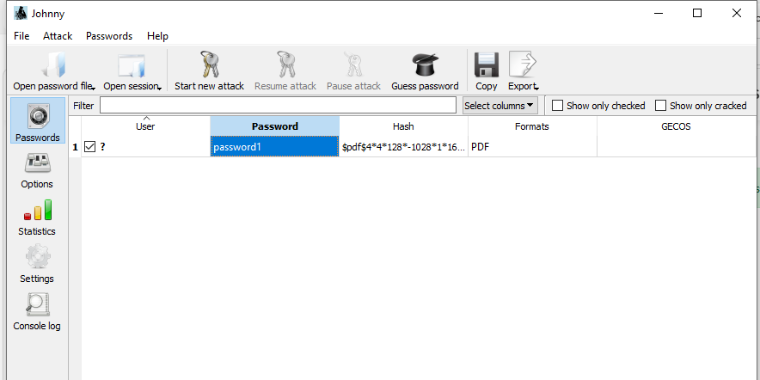

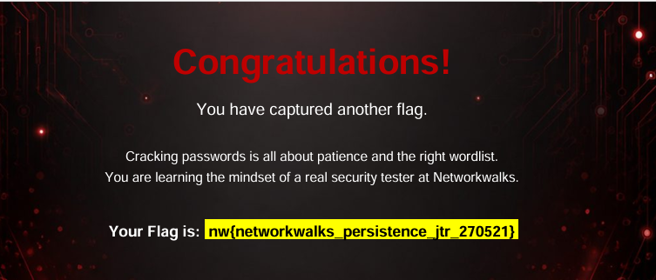
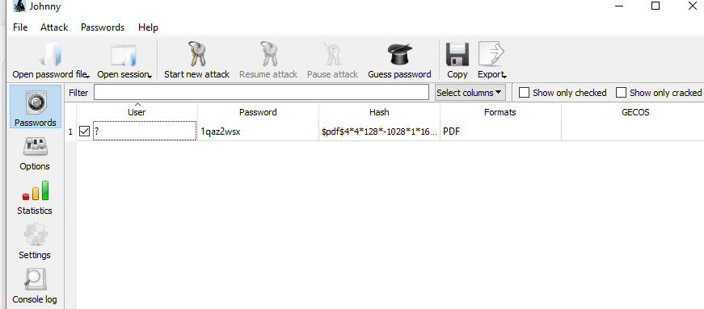


7.2.Using Networkwalks Tools
